IDYLLWILD WATER DISTRICT
AUGUST 2017 NEWSLETTER
IWD Mission Statement: To provide reliable water& sewer service in a safe, cost effective & environmentally sound manner in accordance with the community needs
WATER METERS – As of July 1, 2017, the moratorium on issuing Water Meter has been lifted. If you would like to apply for a Water Meter, a Water Service Request Form is available to you for a fee of $50.00. You can request this form in person at the office or over the phone. You will have 1 year from the date of issuance to complete and return this form for approval from the General Manager. Once your request form has been approved, a Meter can be installed on your property for a capacity fee based on the size of water meter requested and an installation deposit variable to the scope of work required to install the meter. If you have any questions, please call the office at 951-659-2143.

STAFF RECOGNITION – Idyllwild Water District would like to recognize our employee, Joe Reyes. After years of hard work and dedication, Joe has earned his Water Distribution III and Water Treatment III Certifications. These are the highest Certifications that can be earned working at the Idyllwild Water District because we have a Grade II Distribution and Treatment system. Joe also has earned an Associate of Science Degree in Water Technology.

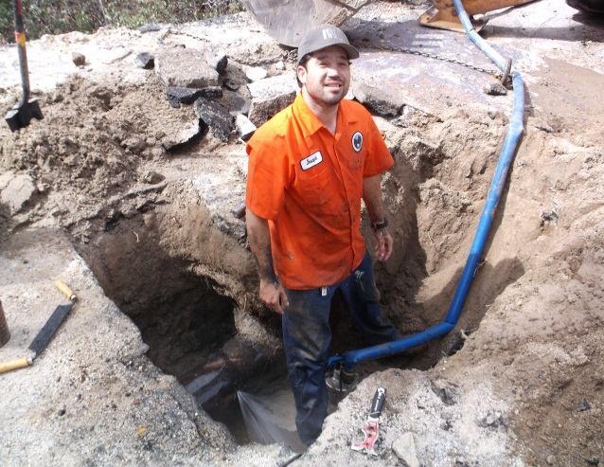

PIPELINE REPLACEMENT – Idyllwild Water District will be working with Genesis Construction to replace approximately 3,000 linear ft. of pipeline on Marian View Drive, Bicknell Drive, Cedar Street and Reed Lane. The Construction for this project will begin late August. Idyllwild Water District has contracted Webb Associates to manage the Construction. Webb Associates is also the design engineer of the project.

BILLING – As some of you know, Idyllwild Water District has upgraded the Billing System. With this upgrade, there have been some changes. Automatic payments with a Credit Card are no longer offered. The only form of Automatic Payment is through ACH Draft. If you are set up for ACH Draft, your checking account will be debited the amount of your bill on the 28th of every month. If you would like to enroll in this program, please submit a VOIDED check from the account you wish to be drafted automatically every month. As always, you can pay your bill with Cash or Check by mail and in person at the office. Credit Cards are accepted on our website www.idyllwildwater.com and in person at the office for a small fee. Please pay your bill on time to avoid Penalties.

Please join us at the August 16th Board meeting at 6:00 p.m.

